VISUAL ODOMETRY
EVALUATION GUIDE
Build, launch, and verification procedure for the OAK-D visual odometry package
ROS 2 • OAK-D Camera
Version 1.0
Date: July 2026

Table of Contents
1. Overview
2. System Architecture
3. Prerequisites
4. Installation
5. Build, Launch, and Verify Workflow
6. Expected Output
7. Troubleshooting

1. Overview
This document describes the steps required to build and run the OAK-D Visual Odometry package and verify that the visual odometry data is being published successfully.

2. System Architecture
The diagram below shows how RGB and depth data flow from the camera through the visual odometry node to downstream consumers.
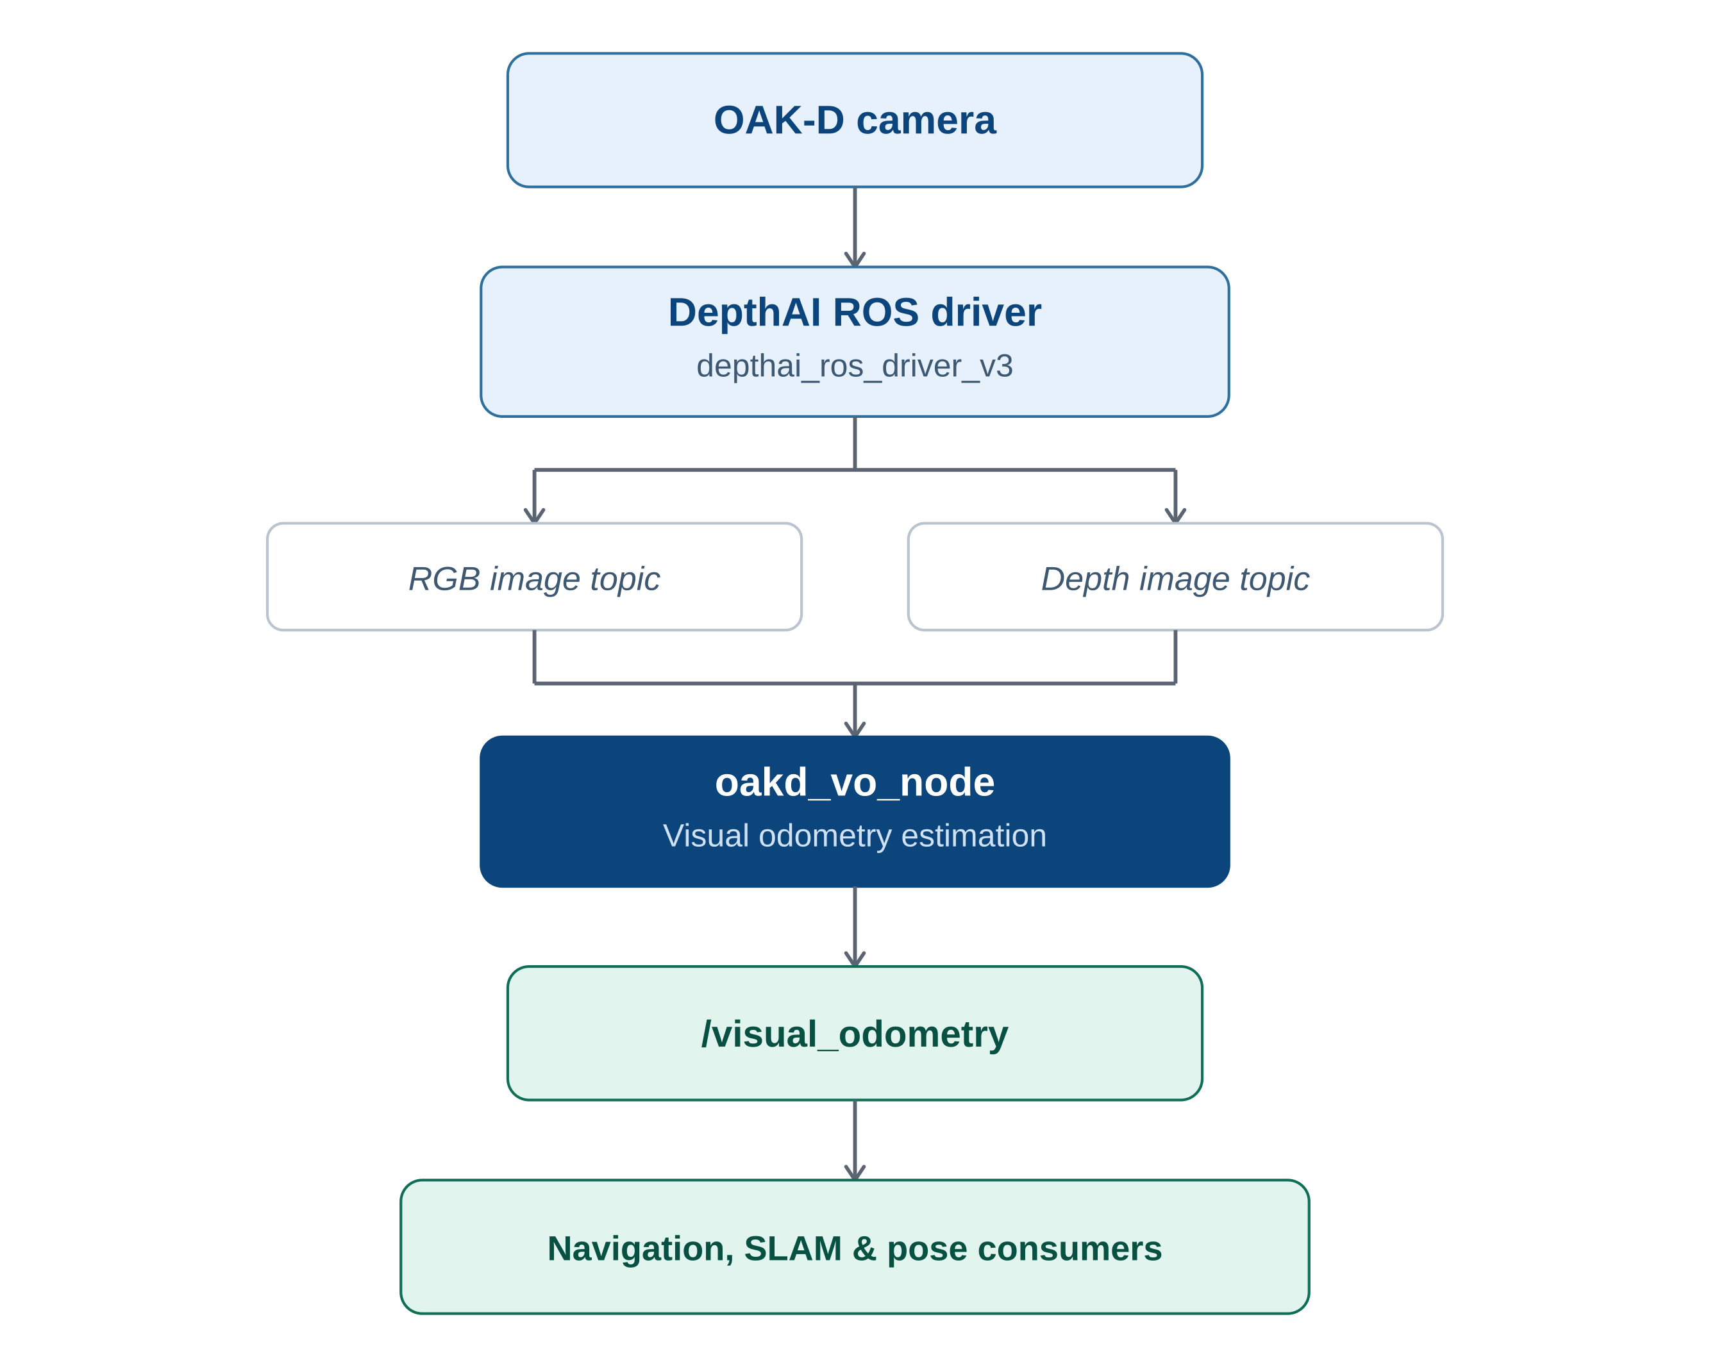
Figure 1 — Visual odometry system architecture

3. Prerequisites
✓ ROS 2 workspace is already created.
✓ depthai_ros_driver_v3 package is installed and working.
✓ OAK-D camera is connected to the system.
✓ ROS 2 environment is properly configured.

4. Installation
Copy the oakd_vo package into the src directory of your ROS 2 workspace.
<ros2_workspace>/
└── src/
├── oakd_vo/
└── ...

5. Build, Launch, and Verify Workflow
The diagram below summarizes the full sequence from building the package to observing live odometry updates.
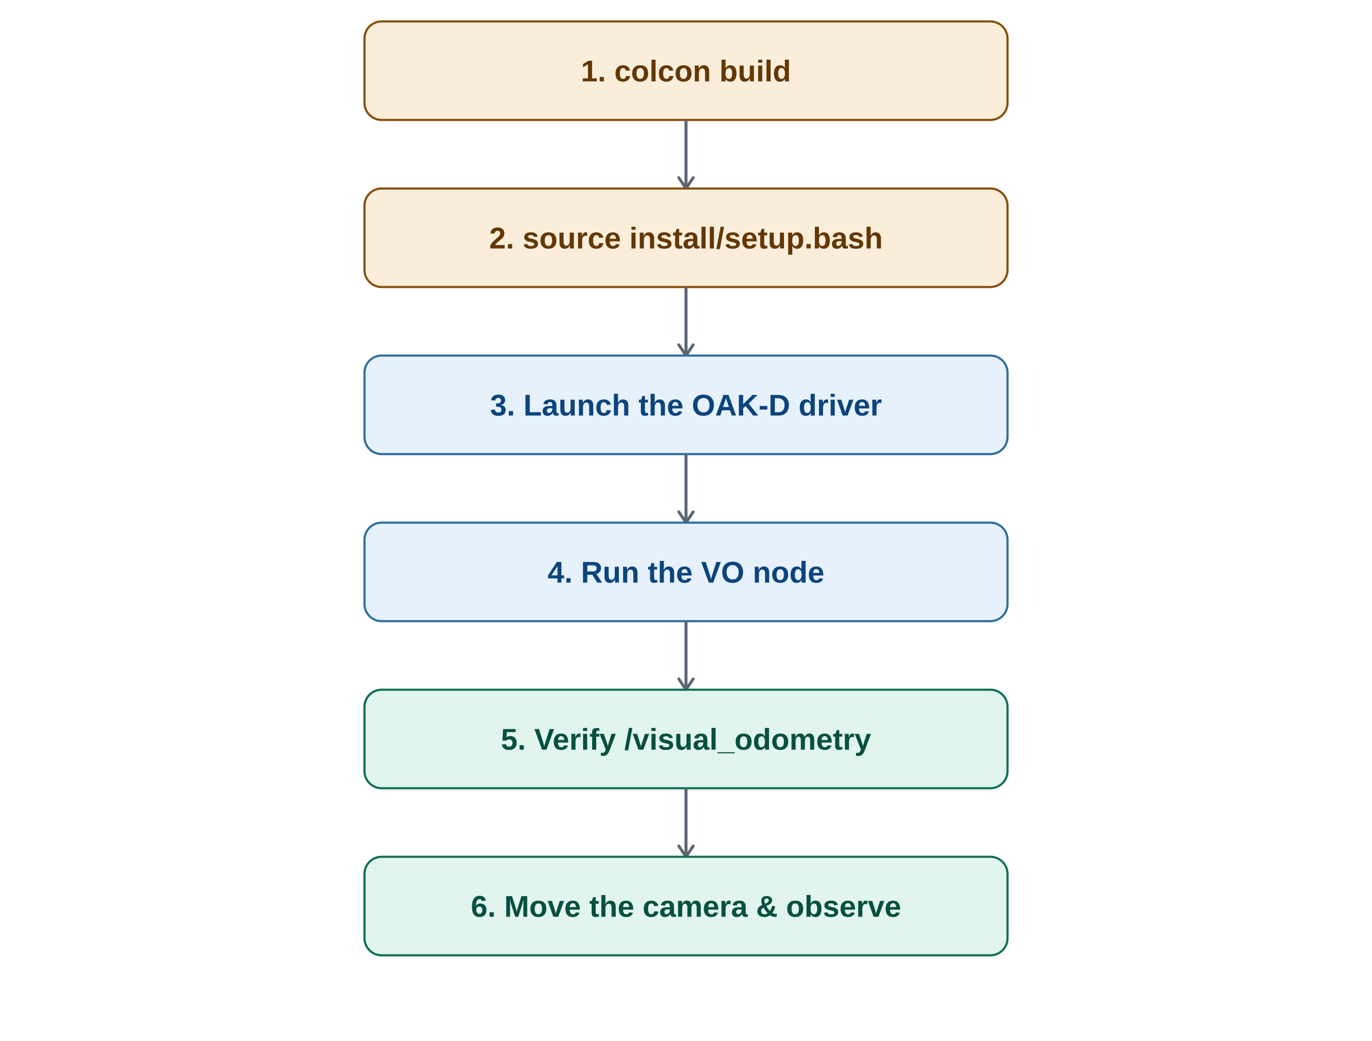
Figure 2 — Build, launch, and verification workflow

Build the Package
Navigate to the root of your ROS 2 workspace and build the complete workspace:
colcon build --symlink-install
...or build only the Visual Odometry package:
colcon build --packages-select oakd_vo

Source the Workspace
After the build completes successfully, source the workspace.
source install/setup.bash

Launch the OAK-D Camera Driver
Start the OAK-D camera by launching the DepthAI ROS driver, and wait until it starts publishing the required RGB and depth topics.
ros2 launch depthai_ros_driver_v3 driver.launch.py

Run the Visual Odometry Node
Open a new terminal, source the workspace again, and execute:
source install/setup.bash
ros2 run oakd_vo oakd_vo_node

Verify Visual Odometry Output
Once the node is running successfully, it will begin publishing the estimated robot pose on /visual_odometry. Verify the topic using:
ros2 topic list
ros2 topic echo /visual_odometry
You should observe a continuous stream of odometry messages containing the estimated position and orientation of the camera.

6. Expected Output
If the system is operating correctly:
✓ The OAK-D camera launches without errors.
✓ The Visual Odometry node starts successfully.
✓ The /visual_odometry topic is created.
✓ Odometry messages are continuously published as the camera moves.
✓ The estimated trajectory changes according to the camera motion.
Example:
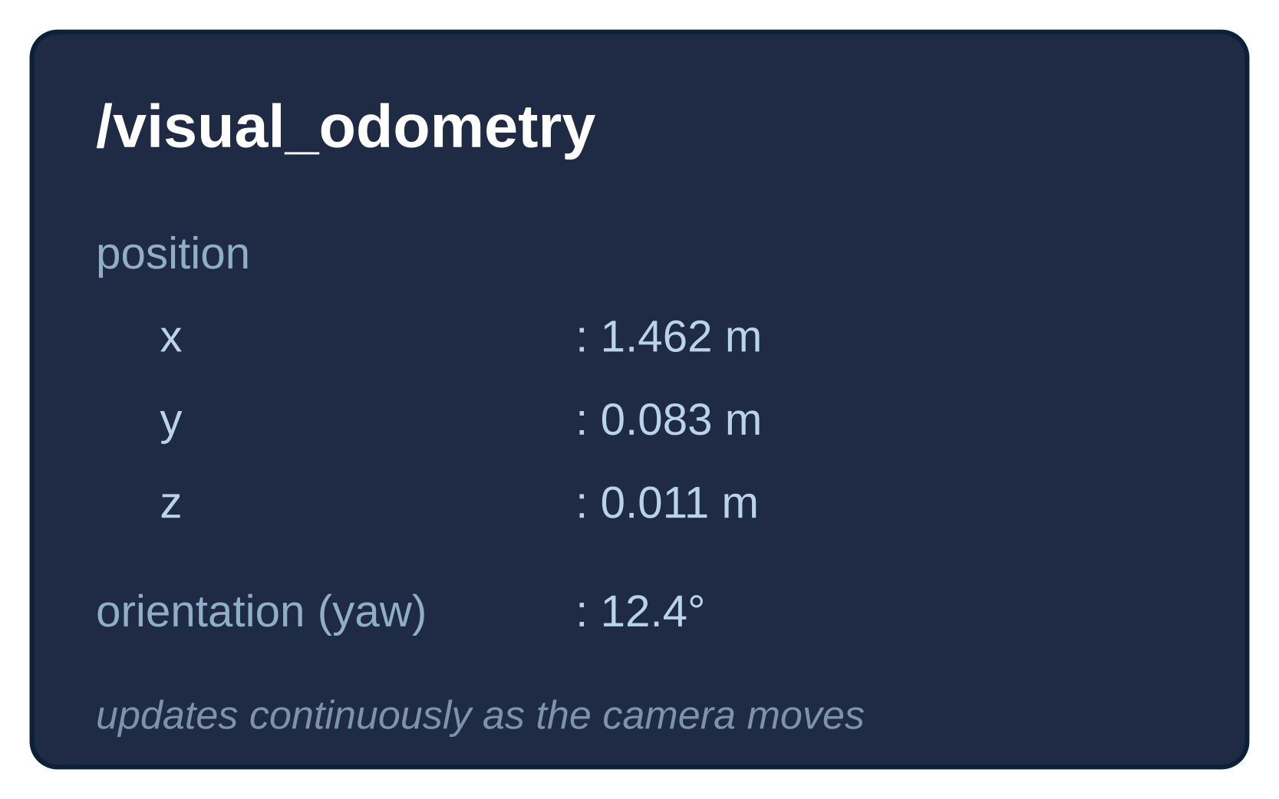
Figure 3 — Example /visual_odometry message

7. Troubleshooting
Issue | Possible Cause | Solution
/visual_odometry topic not available | OAK-D driver not running | Launch the camera driver before starting the VO node.
No odometry updates | Camera is stationary | Move the camera to generate visual features for motion estimation.
Build errors | Workspace not sourced or dependencies missing | Rebuild the workspace and source install/setup.bash.
Camera topics | OAK-D not detected | Verify USB connection and ensure the camera driver launches successfully.

ros2 launch vesc_driver vesc_driver_node.launch.py

